BIT 4107 – Mobile Application Development
ENHANCED PROFESSIONAL STUDENT LOGBOOK
Student Name: BRIAN MUSEMBI
Admission Number: BIT/2024/33660
School/Faculty: COMPUTING AND INFORMATICS
Programme: INFORMATION TECHNOLOGY
Academic Year: FOURTH
Semester: ONE
Lecturer: MICHEAL NYORO
Phone Number: 0798251816

Contents
BIT 4107 – Mobile Application Development 1
Table of figures 3
Week 1: Introduction to Mobile Application Development 4
Week 2: Mobile Development Environment 8
Week 3: User Interface Design 10
Week 4: Event Handling and User Interaction 17
Week 5: Data Management 21
Week 6: Networking and APIs 22
Week 7: Application Architecture 25
Week 8: Event Handling and User Interaction 28

Table of figures
Figure 1: Creating a new Expo project using npx create-expo-app 4
Figure 2 5
Figure 3: App running successfully on Expo Go mobile app 7
Figure 4: VS Code with React Native extension installed 8
Figure 5: Running npx expo start and metro bundler output 8
Figure 6: Debugging configuration in VS Code 9
Figure 7: Home screen with bus listings and destination filters 12
Figure 8: BusCard component showing trip details 14
Figure 9: Interactive seat selection interface 16
Figure 10: Handling trip selection and navigation to booking screen 17
Figure 11: Seat Selection 18
Figure 12: Passenger details form with validation 20
Figure 13: AsyncStorage implementation for persistent data 21
Figure 14: Retrieving and displaying saved bookings 21
Figure 15: Context API Implentation 22
Figure 16: Error handling 24
Figure 17 24
Figure 18: Organized project structure following separation of concerns 25
Figure 19: Typesript interfaces defining data models 26
Figure 20: Component architecture and reusability pattern 26
Figure 21: TouchableOpacity handling tap gestures on BusCard component 28
Figure 22: Touch interaction handling for seat selection 29
Figure 23: Keyboard input handling with TextInput components 30
Figure 24: Input validation logic for booking form 31
Figure 25: Swipe gesture handling with RefreshControl 31
Figure 26: Event handling for booking cancellation with confirmation dialog 32

Week 1: Introduction to Mobile Application Development
Practical Activities Undertaken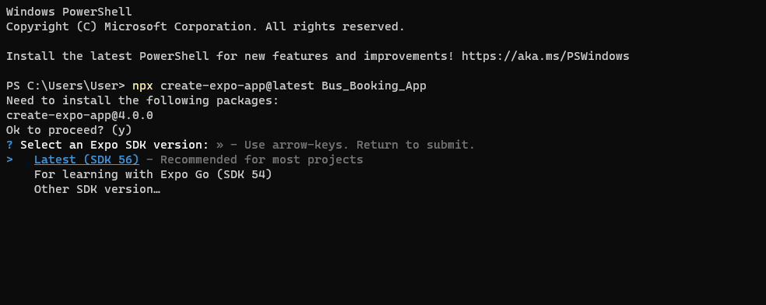
Figure 1: Creating a new Expo project using npx create-expo-app
Screenshots:

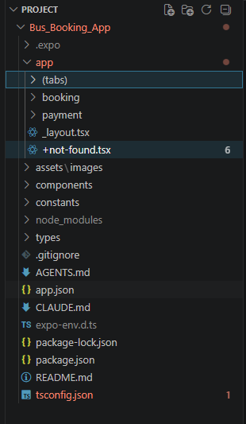
Figure 2
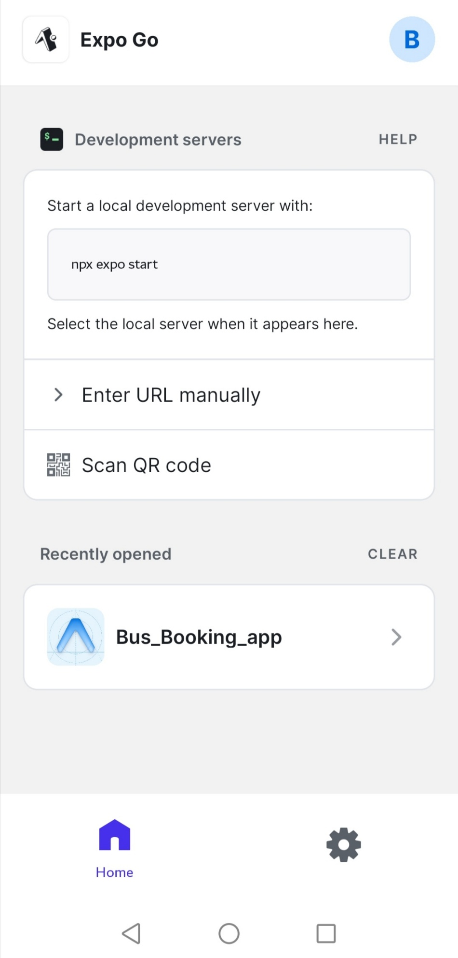
Figure 3: App running successfully on Expo Go mobile app
Tools/Software Used
- Node.js - JavaScript runtime for development
- Expo CLI - Framework for building React Native apps
- Visual Studio Code - Code editor with React Native extensions
- Expo Go App - Mobile app for testing on physical devices
- Git - Version control system
- GitHub - Remote repository hosting
Personal Reflection
This week provided a solid foundation in mobile development. Setting up the environment was straightforward with Expo. Understanding the difference between React Native and Expo was crucial. The most valuable lesson was learning how Expo simplifies the development process, eliminating the need for native build tools initially.

Week 2: Mobile Development Environment
Practical Activities Undertaken
Screenshots:
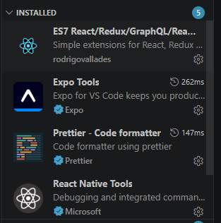
Figure 4: VS Code with React Native extension installed
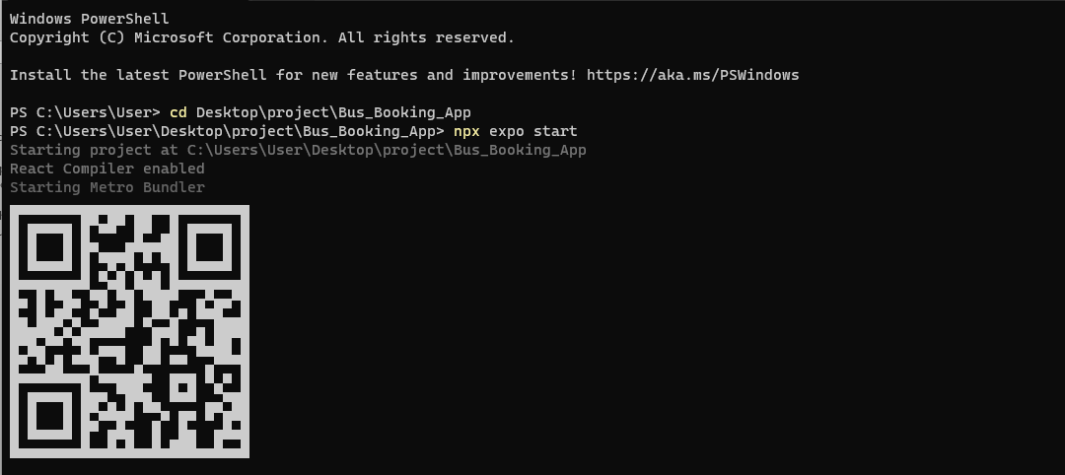
Figure 5: Running npx expo start and metro bundler output

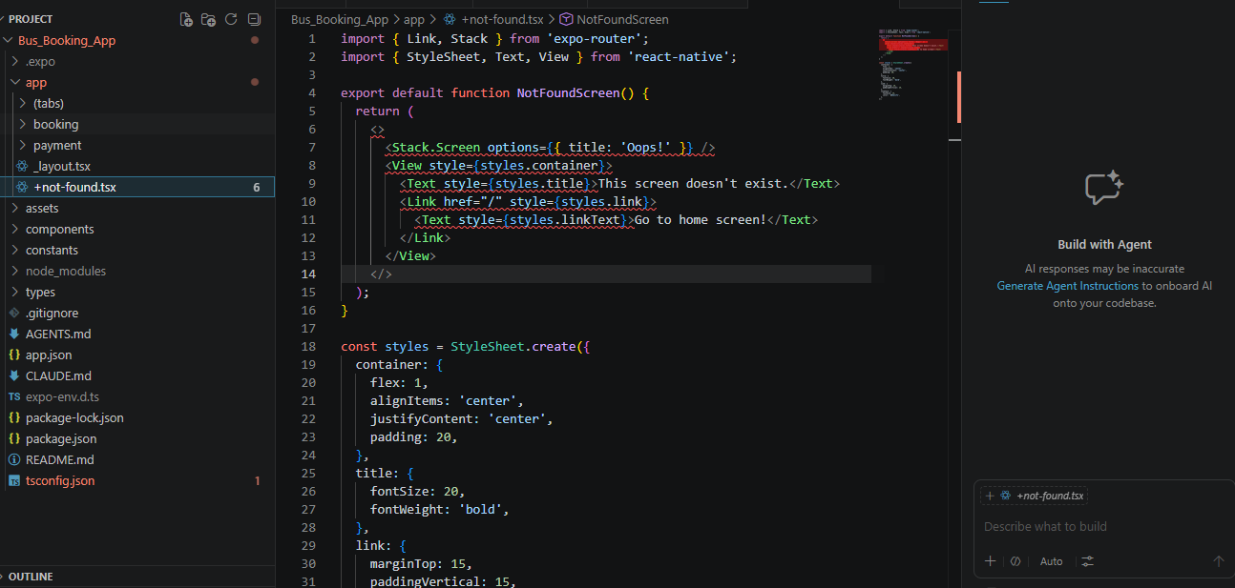
Figure 6: Debugging configuration in VS Code
Tools/Software Used
- VS Code Extensions: React Native Tools, ESLint, Prettier
- Expo CLI - Development server and build tools
- Android Studio - Android emulator
- Git & GitHub - Version control and collaboration
- Terminal/PowerShell - Command-line operations
Personal Reflection
Setting up the development environment was crucial for smooth development. I learned how to configure VS Code for optimal React Native development, including debugging tools and code formatting. The PowerShell execution policy issue was challenging but taught me to troubleshoot environment-specific problems. Understanding the development workflow from code to device is now clear.

Week 3: User Interface Design
Practical Activities Undertaken
Screenshots:
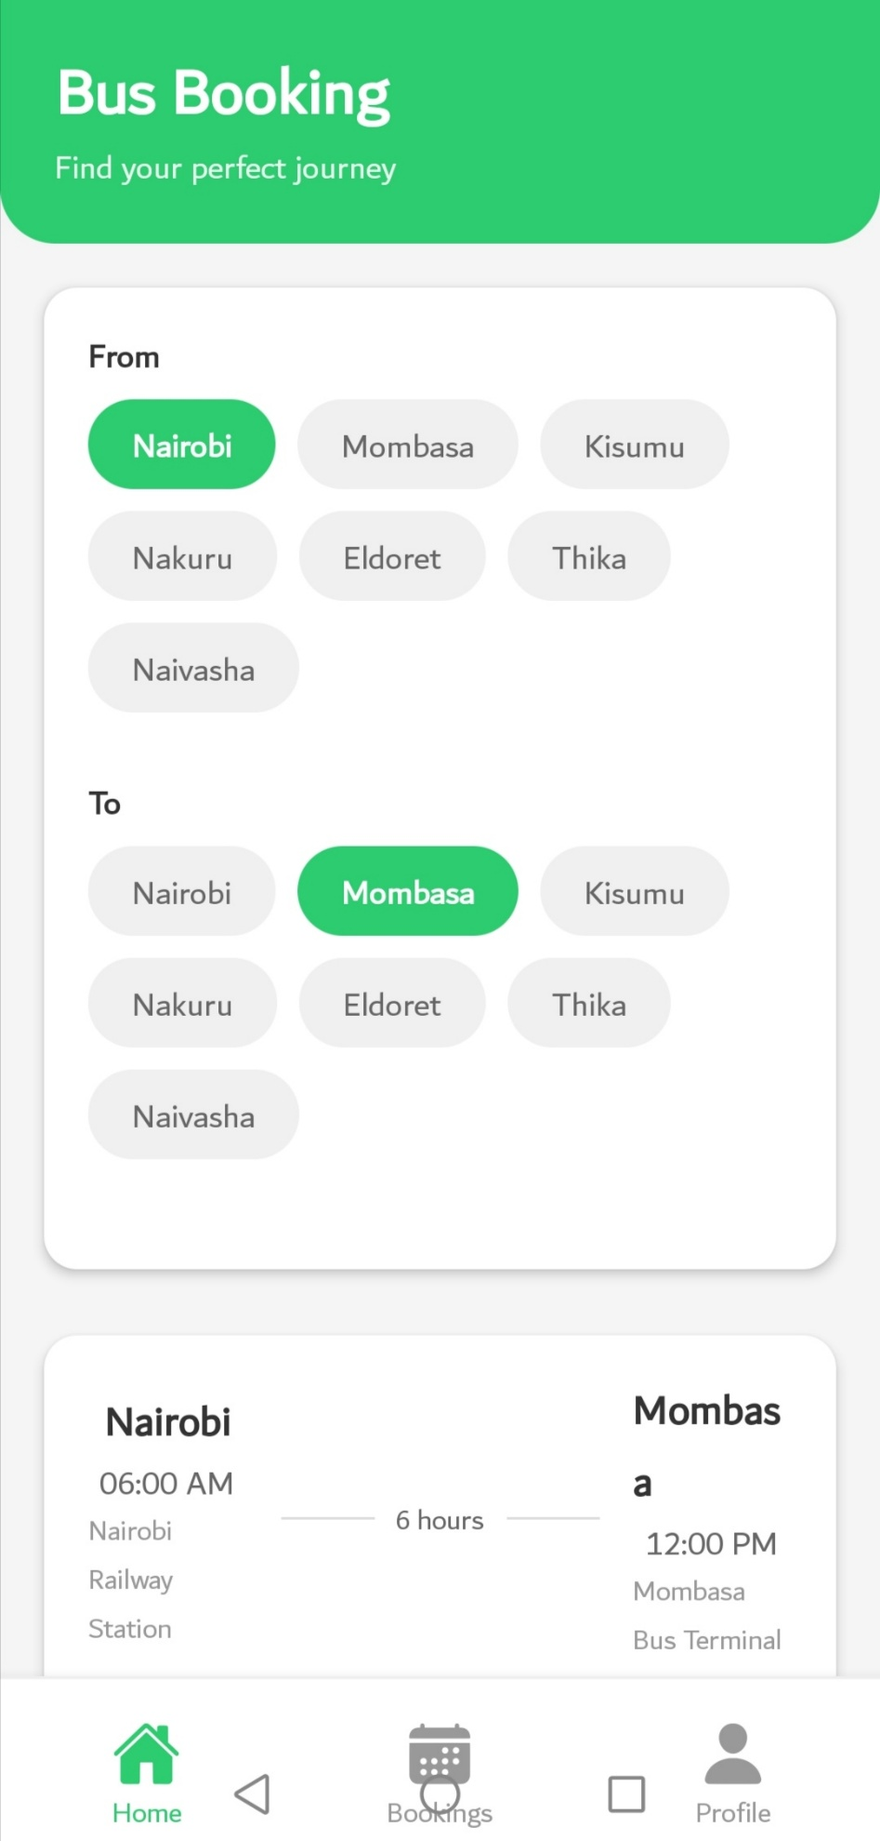
Figure 7: Home screen with bus listings and destination filters

Figure 8: BusCard component showing trip details
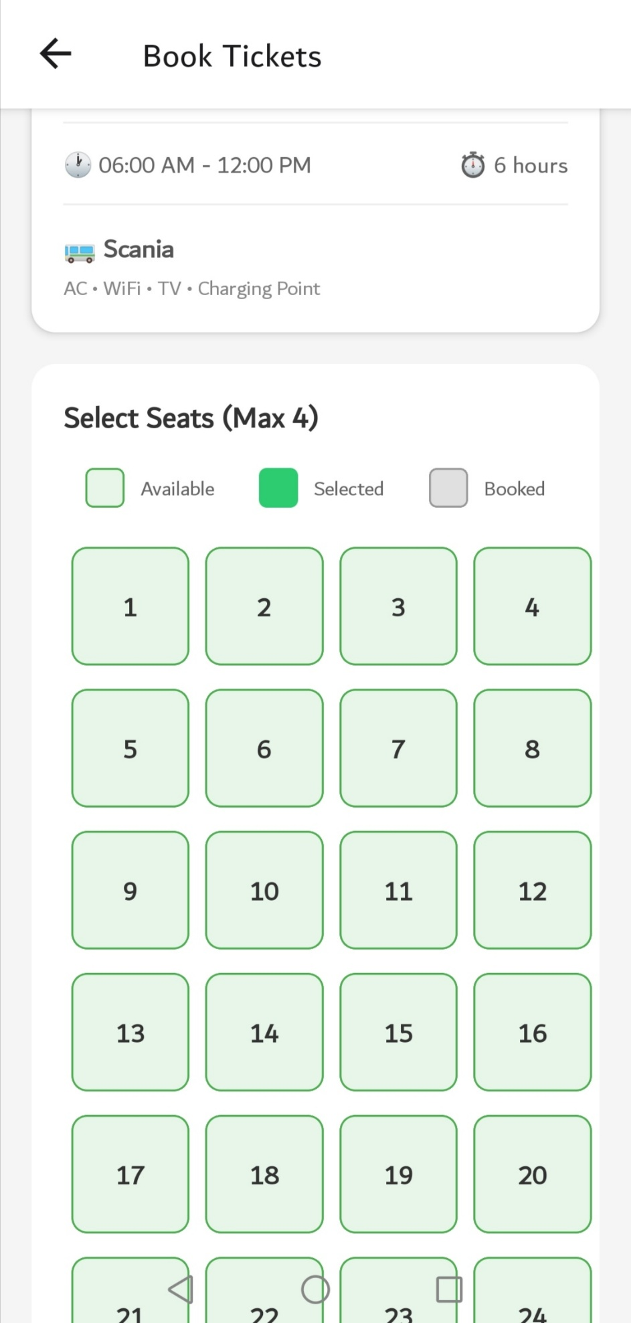
Figure 9: Interactive seat selection interface
Tools/Software Used
- React Native Components: View, Text, TouchableOpacity, ScrollView
- StyleSheet - Styling in React Native
- Flexbox Layout - Responsive UI design
- Expo Vector Icons - Icon library for app icons
- React Navigation - Tab and stack navigation
Personal Reflection
Designing mobile interfaces requires careful consideration of touch targets, spacing, and visual hierarchy. I learned how Flexbox in React Native differs from CSS Flexbox. Creating reusable components like BusCard improved code maintainability. The seat selection grid was particularly challenging but taught me about dynamic rendering and state management in React Native.

Week 4: Data Management
Practical Activities Undertaken
Screenshots:
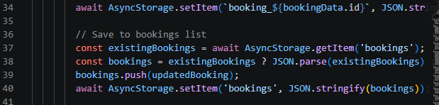
Figure 13: AsyncStorage implementation for persistent data
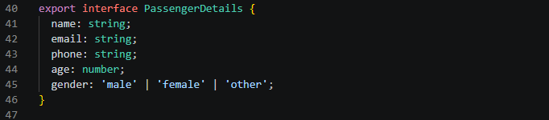
Figure 14: Retrieving and displaying saved bookings
Tools/Software Used
- AsyncStorage - Local data persistence
- JSON Serialization - Data storage format
- React Hooks - State management
- TypeScript Interfaces - Type safety for data
- Array Methods - Data manipulation (filter, map, find)
Personal Reflection
Data management is critical for mobile apps that need to persist user information. I learned how to store, retrieve, and update data using AsyncStorage. Understanding JSON serialization and deserialization was key. Creating the booking system with status tracking and cancellation functionality taught me about data integrity and user state management. The challenge was maintaining consistent data across the app.

Week 5: Networking and APIs
Practical Activities Undertaken
Screenshots: 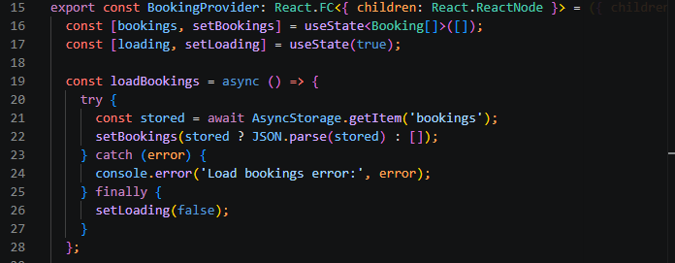
Figure 15: Context API Implentation
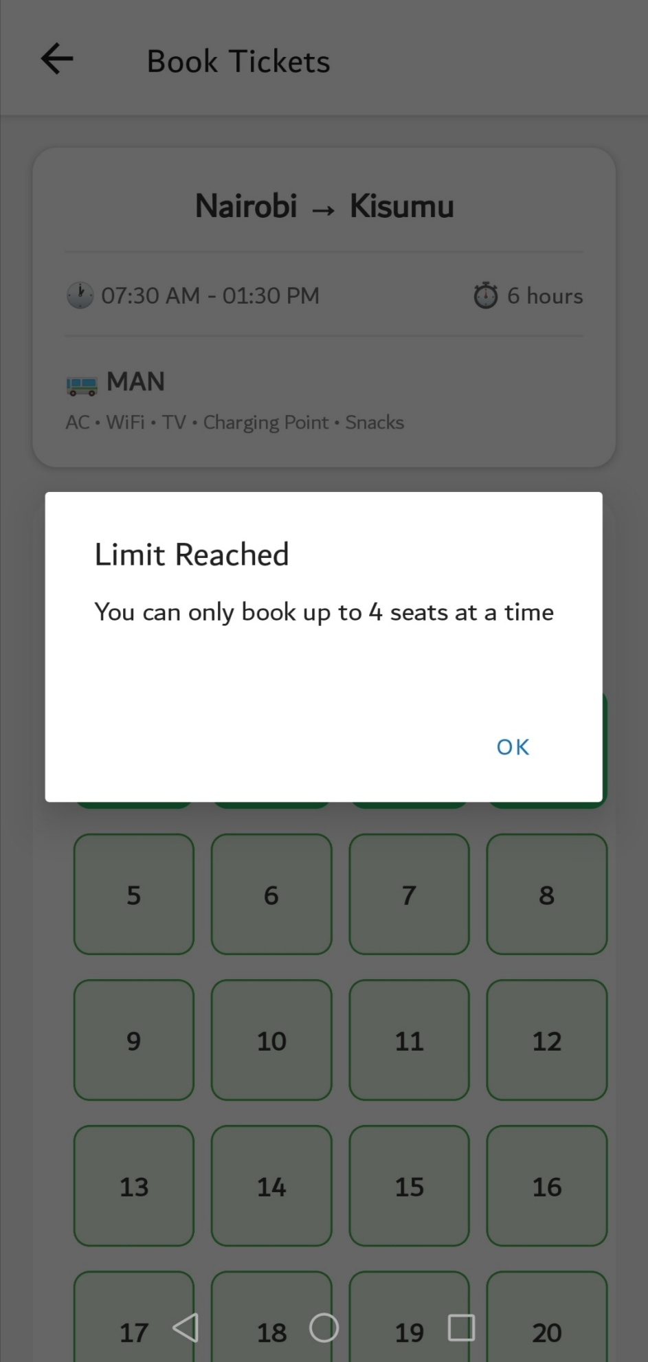
Figure 16: Error handling

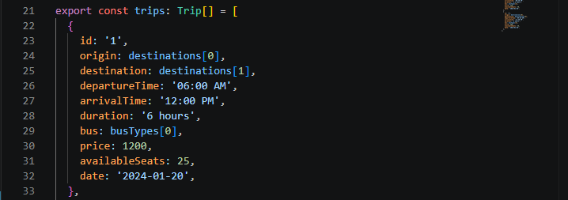
Figure 17
Tools/Software Used
- Fetch API - HTTP requests
- Async/Await - Asynchronous operations
- JSON - Data exchange format
- Mock APIs - Simulated backend (JSON server or similar)
- Error Handling - Try-catch blocks for network errors
- Loading States - User feedback during network requests
Personal Reflection
Networking is essential for modern apps that require real-time data. I learned how to make HTTP requests using the Fetch API and handle responses asynchronously. Implementing loading states and error handling improved user experience. Understanding the importance of API integration for real-time seat availability and booking management was eye-opening. Future implementation with a real backend would make the app fully functional.

Week 6: Application Architecture
Practical Activities Undertaken
Screenshots:
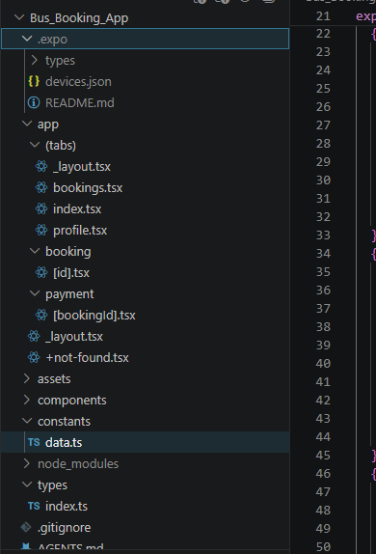
Figure 18: Organized project structure following separation of concerns

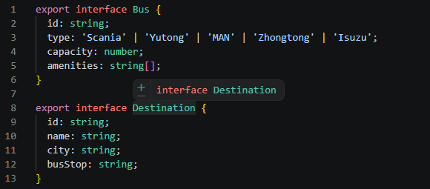
Figure 19: Typesript interfaces defining data models

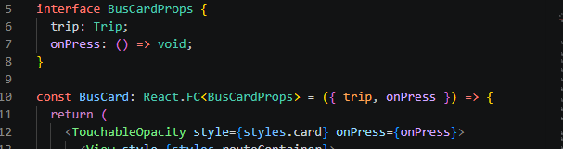
Figure 20: Component architecture and reusability pattern

Tools/Software Used
- Folder Structure - Organized project architecture
- TypeScript - Type safety and interfaces
- Component Pattern - Reusable UI components
- Separation of Concerns - Divided code by functionality
- Constants File - Centralized data management
- Type Definitions - Consistent data models
Personal Reflection
Application architecture determines code maintainability and scalability. I learned how to organize a React Native project following best practices: separating components, constants, types, and screens. Using TypeScript interfaces ensured type safety across the app. The component-based architecture allowed for code reusability, making the app easier to maintain. Understanding the flow of data from constants through components to screens was crucial.

Week 7: Event Handling and User Interaction
1. Practical Activities Undertaken
Screenshot 1: Touch Gesture Handling - Press Event
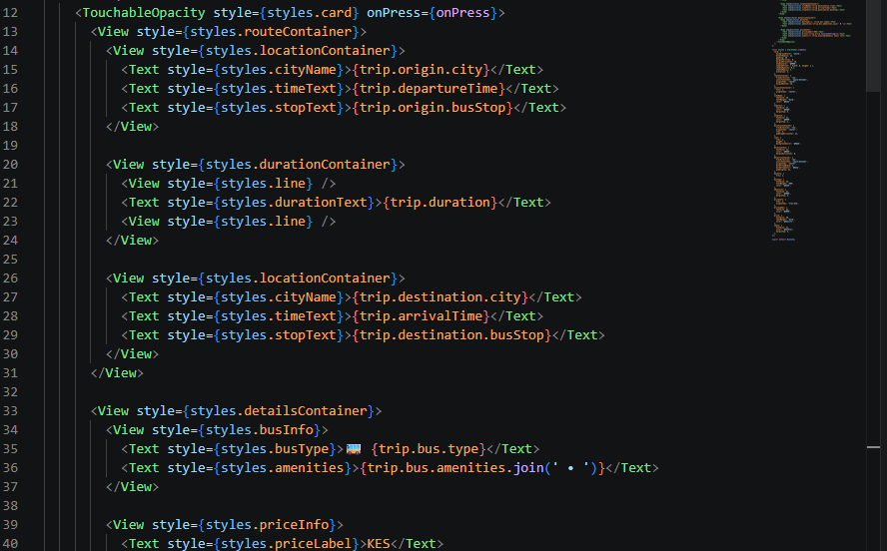
Figure 21: TouchableOpacity handling tap gestures on BusCard component

Screenshot 2: Seat Selection - Touch Interaction
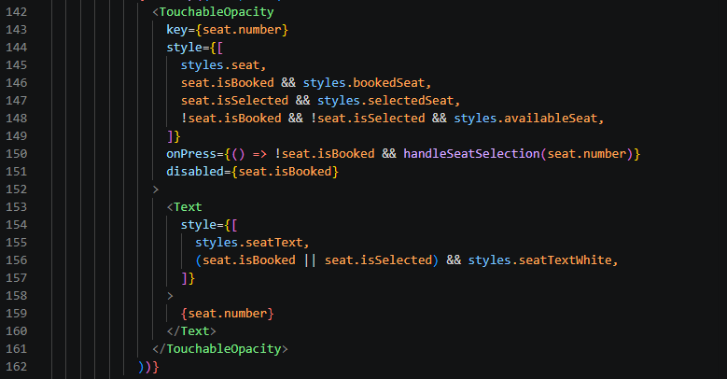
Figure 22: Touch interaction handling for seat selection

Screenshot 3: Form Input Handling - TextInput with Validation
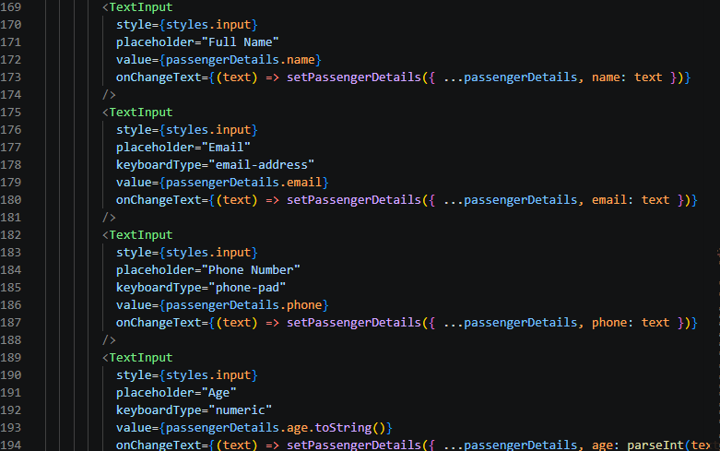
Figure 23: Keyboard input handling with TextInput components

Screenshot 4: Input Validation - Form Validation Logic
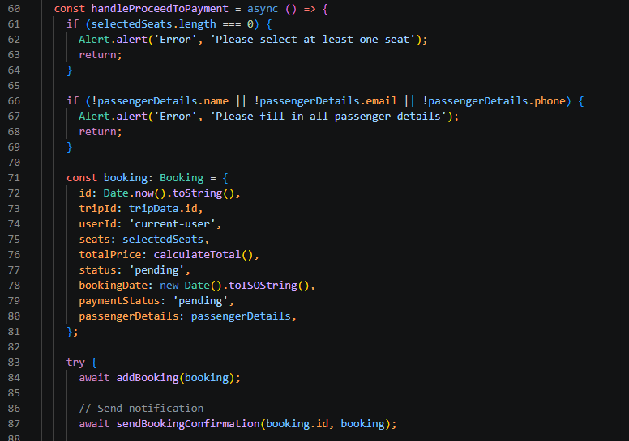
Figure 24: Input validation logic for booking form

Screenshot 5: Gesture Handler - Long Press and Swipe
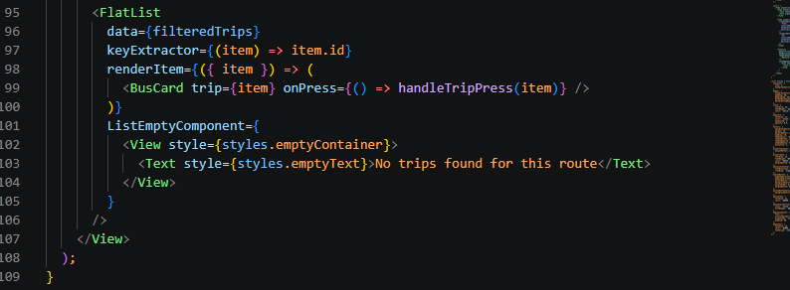
Figure 25: Swipe gesture handling with RefreshControl
Screenshot 6: Event Handler - Booking Cancellation
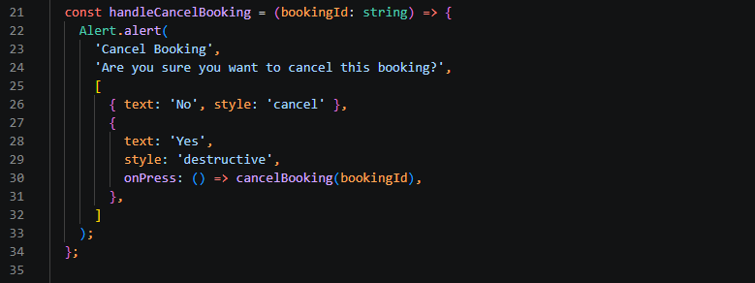
Figure 26: Event handling for booking cancellation with confirmation dialog

2. Tools/Software Used
Tool/Software | Purpose
Visual Studio Code | Primary code editor for developing the application
React Native | Framework for building the mobile app
TypeScript | Programming language for type-safe code
Expo CLI | Development server and build tools
Expo Go App | Testing the app on physical devices
React Native Components | TouchableOpacity, TextInput, FlatList for handling interactions
React Hooks | useState, useEffect for state management
Git & GitHub | Version control and code hosting
Terminal/PowerShell | Running commands and managing the project
React Native Alert API | User feedback and confirmations

3. Personal Reflection
This week's focus on event handling enhanced my understanding of mobile interactions. Implementing touch gestures, keyboard input validation, and form handling in the bus booking app improved user experience. The seat selection logic and cancellation confirmation were particularly valuable for learning real-world event-driven programming.

